Parkview Residential Care Home

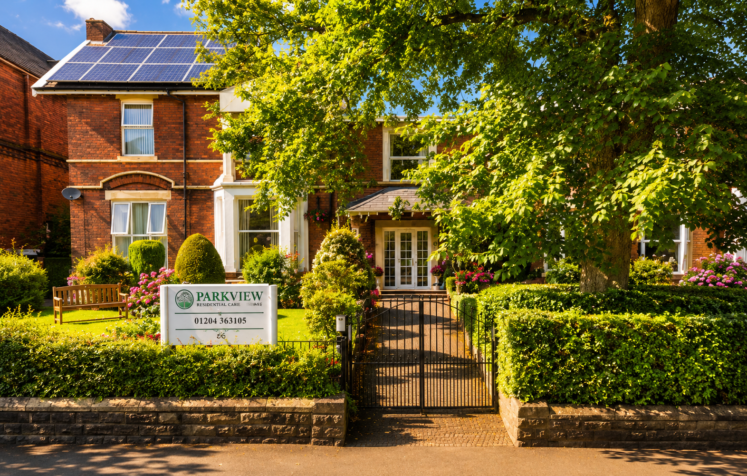
FAMILY GUIDE

OUR PHILOSOPHY OF CARE
At Parkview Residential Home, our mission is to provide compassionate, person-centred care in a safe, welcoming and respectful environment where every resident feels valued, supported and at home.
We are dedicated to promoting dignity, independence, wellbeing and quality of life through meaningful relationships, professional care and a commitment to treating every individual with kindness, empathy, and respect.
We are situated opposite Queen’s Park in Bolton. Our home accommodates up to 35 residents and offers personalised support tailored to individual needs and abilities.
We work closely with residents, families, and healthcare professionals to ensure care is delivered with kindness, respect and compassion at all times.


Queen’s Park – Bolton
A beautiful park on our doorstep

WE OFFER PERSONALISED CARE AND SUPPORT FOR INDIVIDUALS LIVING WITH:
- Stroke recovery
- Acquired brain injuries
- Respite and convalescent care

- Dementia and Alzheimer’s
- Physical disabilities
- Mental health needs
- Parkinson’s disease
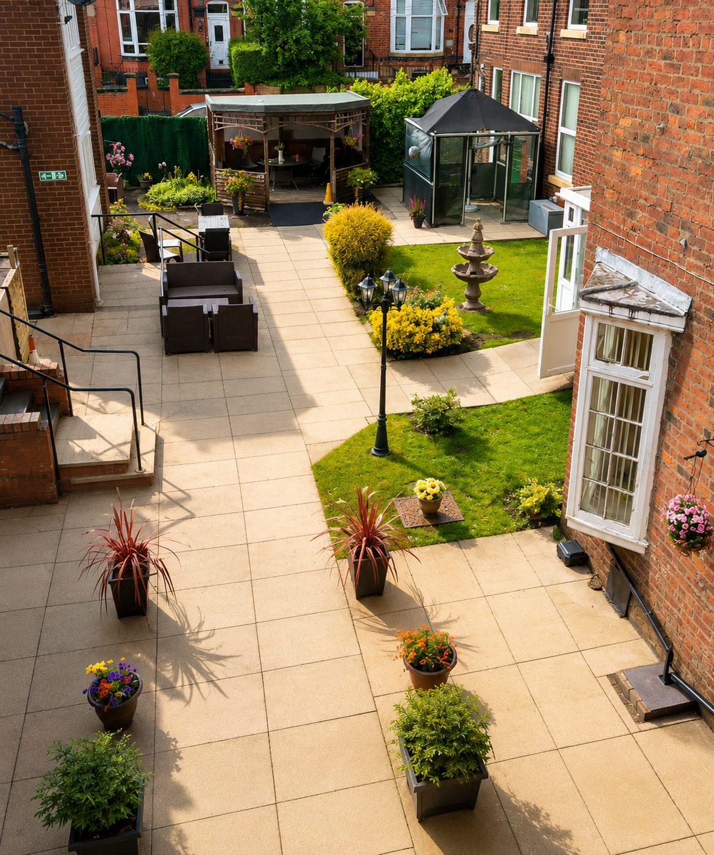
At Parkview, we encourage residents to remain active, socially connected, and involved in everyday life. Regular activities, celebrations, visiting community groups, and family forums help create a warm and vibrant atmosphere where everyone feels valued and included.

OUR PHILOSOPHY IS BUILT AROUND:
Integrity • Compassion • Accountability • Respect • Engagement
We continually strive for excellence in care and are committed to creating a place residents are proud to call home.
OUR FACILITIES & SERVICES

24-hour support from trained & dedicated staff
spaces

Pamper parlour for Hairdressing & beauty services

Bright communal lounges & quiet relaxation areas

Beautiful gardens & peaceful outdoor spaces

Comfortable bedrooms, including en-suite options

Wi-Fi, television, & modern safety systems throughout the home spaces

Dedicated laundry & housekeeping team
spaces

Accessible & reliable transport services

Nutritious home-cooked meals with menu choices

Daily activities, entertainment & community engagement

A HOME FROM HOME
PERSON-CENTRED CARE
At Parkview Residential Home, we believe every resident is unique and should receive care that suits their individual needs, preferences, and routines. We work closely with residents, families, and healthcare professionals to provide support that promotes dignity, independence, and wellbeing.
DIGNITY AND RESPECT
We are committed to treating every resident with kindness, respect, and compassion. We support privacy, choice, and independence while making sure residents feel safe, comfortable, and valued in our home.
THE HOUSEHOLD MODEL
We follow a household model of care to create a warm, comfortable, and familiar environment. Residents live as part of a smaller household community where daily life is centred around personal choice, independence, and meaningful relationships. This helps create a true home-from-home atmosphere where residents feel secure, included, and supported in their own routines and way of life.
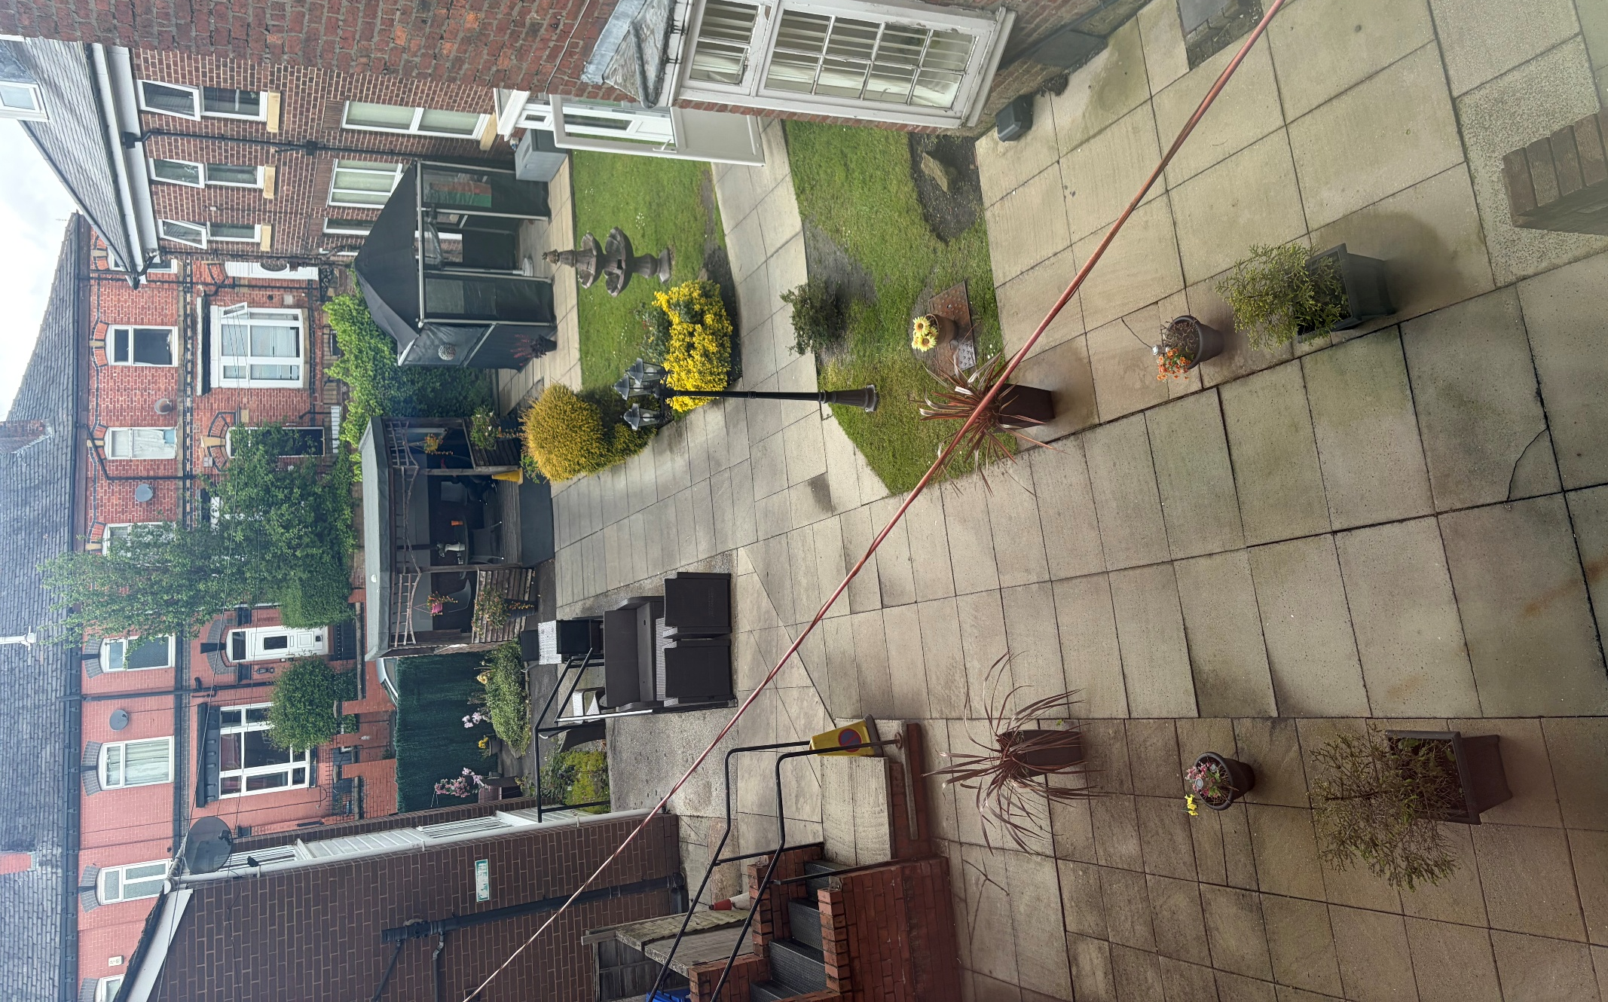
PROMOTING INDEPENDENCE
We encourage residents to stay as independent as possible by supporting them with daily activities and personal choices. Our aim is to help residents maintain confidence, skills, and control over their own lives while providing support when needed.
EMOTIONAL AND SOCIAL WELLBEING
We understand the importance of emotional wellbeing and social connection. Residents are encouraged to take part in activities, hobbies, and social events that bring enjoyment, companionship, and a sense of belonging.
SAFE AND PROFESSIONAL CARE
Our dedicated staff provide high-quality care in a safe, comfortable, and supportive environment. We are committed to maintaining professional standards, ongoing training, and clear communication to ensure the best care for every resident.
STAFF TRAINING
At Parkview Residential Home, we are committed to ensuring all staff receive the training, knowledge, and support needed to provide safe, effective, and compassionate care. Our team takes part in regular mandatory training, professional development, and ongoing learning to maintain high standards of care and meet the individual needs of our residents.
WORKING WITH FAMILIES
We value the important role families and loved ones play in the lives of our residents. We aim to build strong relationships through open communication, involvement in care planning, and ongoing support for both residents and their families.
- Visitors are welcome at convenient times.
- Families may telephone at any time regarding wellbeing.
- Visitors must sign in and follow health and safety guidance.
- Food or hazardous materials should not be brought in without approval.
OUR ENVIRONMENT
A WARM AND WELCOMING HOME
At Parkview Residential Home, we aim to provide a warm, comfortable, and welcoming environment where residents feel truly at home. Our surroundings are designed to be safe, homely, and supportive, helping residents feel relaxed and secure in their daily lives.
FACILITIES INCLUDE:
- 8 en-suite rooms
- 35 single rooms
- TVs, accessible equipment and Wi-Fi
- Notices, meetings and activities are regularly displayed around the home.
- Residents may use the office telephone privately if required.

SAFE AND COMFORTABLE LIVING SPACES
We provide clean, well-maintained, and comfortable living spaces that promote safety and wellbeing. Bedrooms are personalised wherever possible, allowing residents to bring familiar items and create a space that reflects their own personality and preferences. Rooms are allocated according to preference where possible. Privacy and dignity are respected at all times. Residents can call for assistance using in-room call systems. Residents are encouraged to personalise rooms with photos and personal belongings.
SHARED SPACES AND COMMUNITY LIFE
Our communal areas are designed to encourage social interaction, relaxation, and engagement. Residents are welcome to enjoy shared lounges, dining areas, and activity spaces, helping to build friendships and a strong sense of community within the home.
OUTDOOR AREAS
We offer access to safe and pleasant outdoor spaces where residents can enjoy fresh air, gentle exercise, or quiet reflection. These areas provide a calming environment and support both physical and emotional wellbeing.
A CALM AND SUPPORTIVE ATMOSPHERE
We understand the importance of a calm and peaceful environment in promoting comfort and wellbeing. Our home is designed to reduce stress and support residents in feeling settled, secure, and cared for at all times.
MAINTAINING HIGH STANDARDS
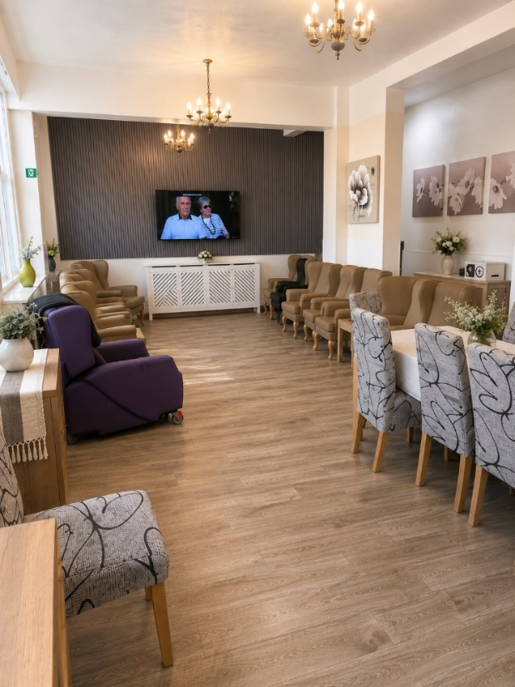
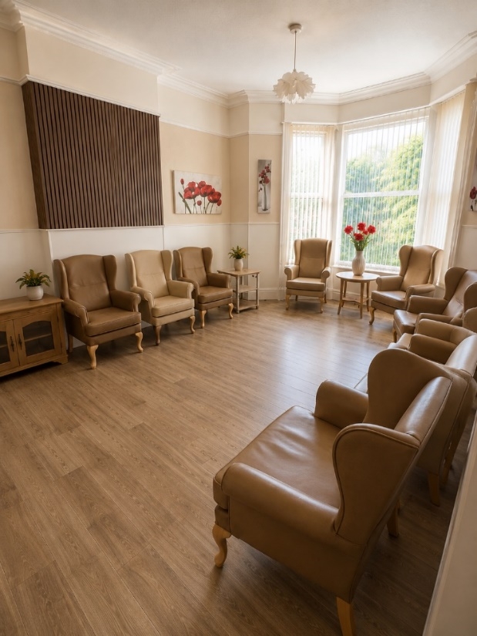
We are committed to maintaining a clean, safe, and well-managed environment through regular checks, upkeep, and continuous improvement. Our team works hard to ensure the home remains a pleasant and supportive place for everyone who lives and visits here.

LIFE AT PARKVIEW RESIDENTIAL HOME
Moving into a care home is a big step. At Parkview Residential Home I quickly discovered a warm, friendly and welcoming place where residents are treated with kindness, dignity and respect every day.
The staff took the time to get to know me personally; my routines, preferences, hobbies and what matters most to me. I feel listened to, supported, and encouraged to remain as independent as possible while knowing help is always available whenever I need it.
My room feels comfortable, homely and I can personalise it with my own belongings and treasured items. I also enjoy spending time in the lounges, peaceful gardens and communal areas where there is always something going on if I want to join in.
There are plenty of activities and opportunities to stay active and social, including games, music, outings, celebrations, exercise sessions, arts and crafts, and visits from community groups. Family and friends are always welcome, which helps me stay connected to the people who are important to me.
The meals are freshly prepared, nutritious and enjoyable, with choices available every day. The staff are always happy to cater for personal preferences and dietary needs.
What stands out most about Parkview is the caring atmosphere. The staff genuinely care about residents’ wellbeing, happiness, and comfort. I feel safe, respected and valued here. Most importantly, I feel at home.
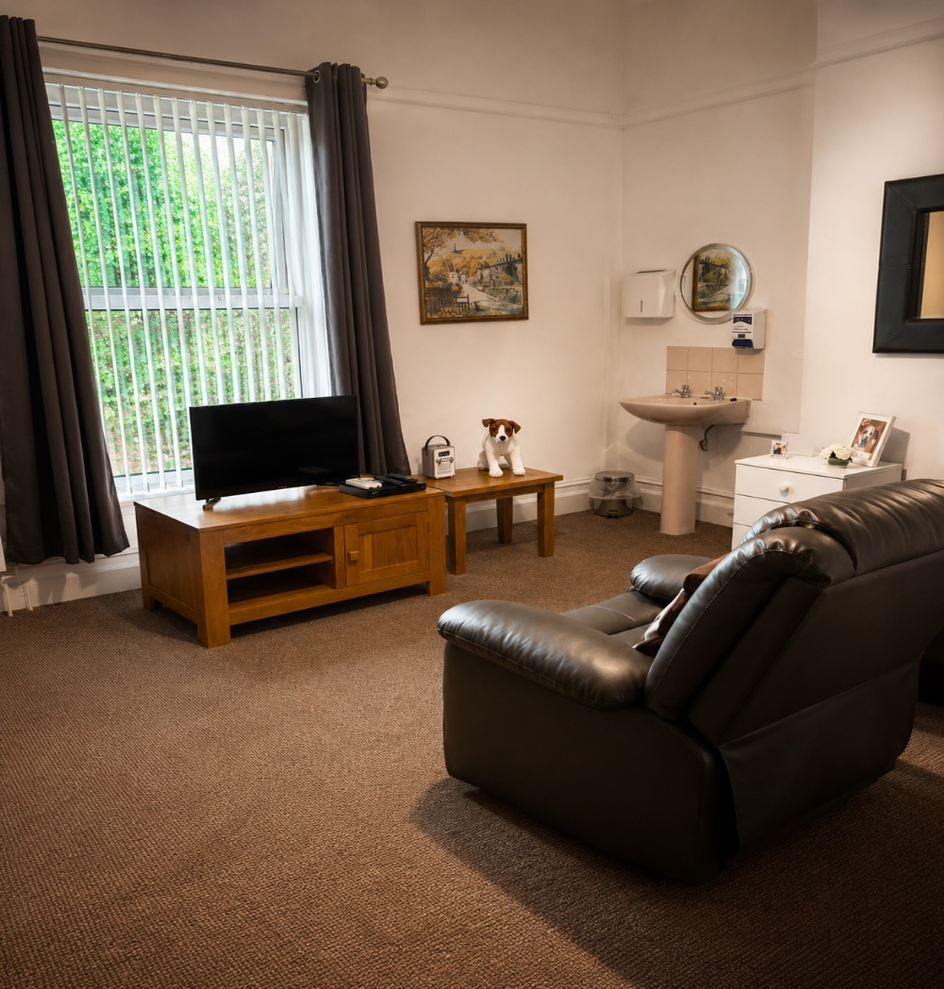
At Parkview Residential Home, residents are supported to live life with dignity, independence, companionship, and peace of mind.

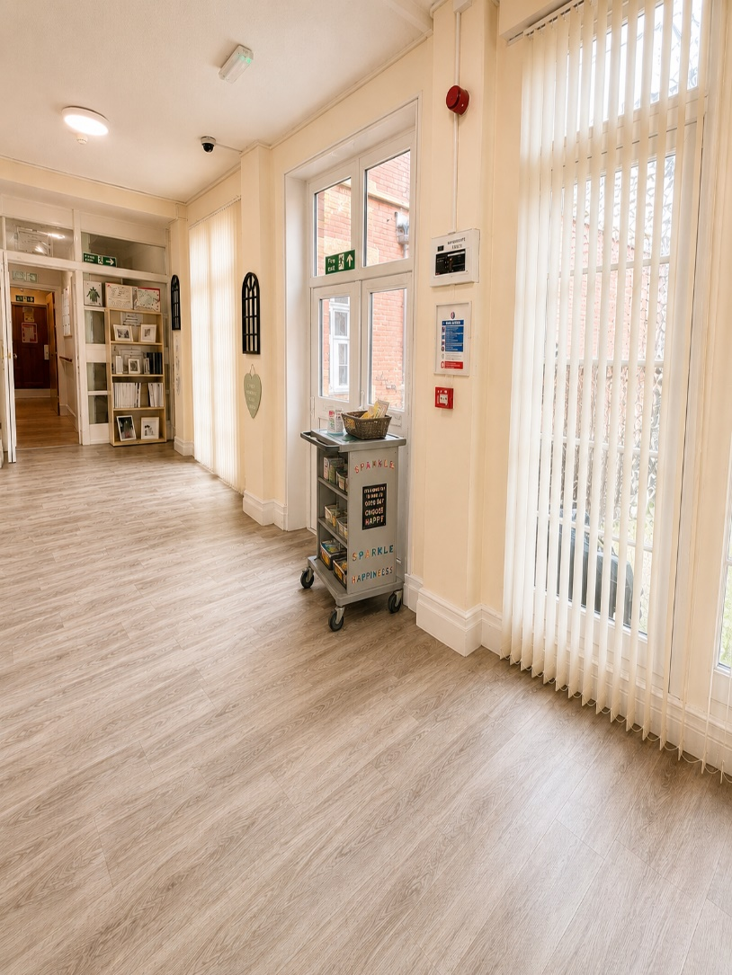
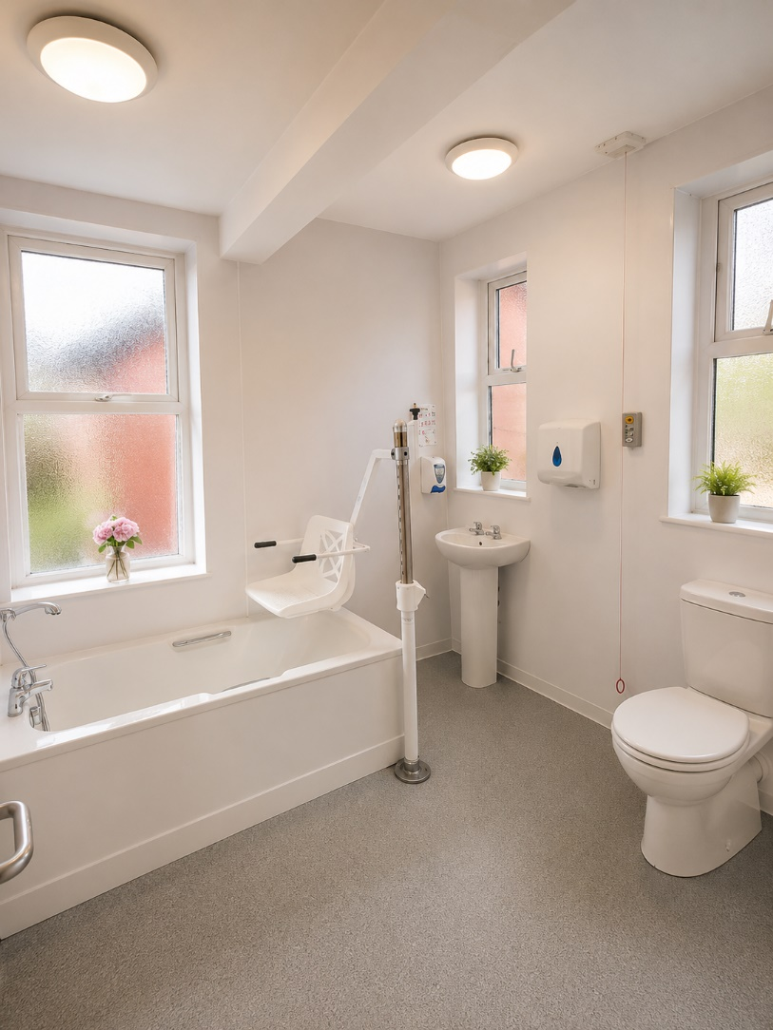

NAVIGATING AROUND OUR HOME
At Parkview Residential Home, we aim to make it simple and reassuring for residents to move around and find their way. The home is laid out in a clear and easy-to-follow way, helping residents feel confident and independent in their daily routines.
Key areas such as bedrooms, lounges, dining rooms, and bathrooms are clearly signposted to support easy navigation. We focus on keeping the environment consistent and familiar so residents can move around safely and with confidence.
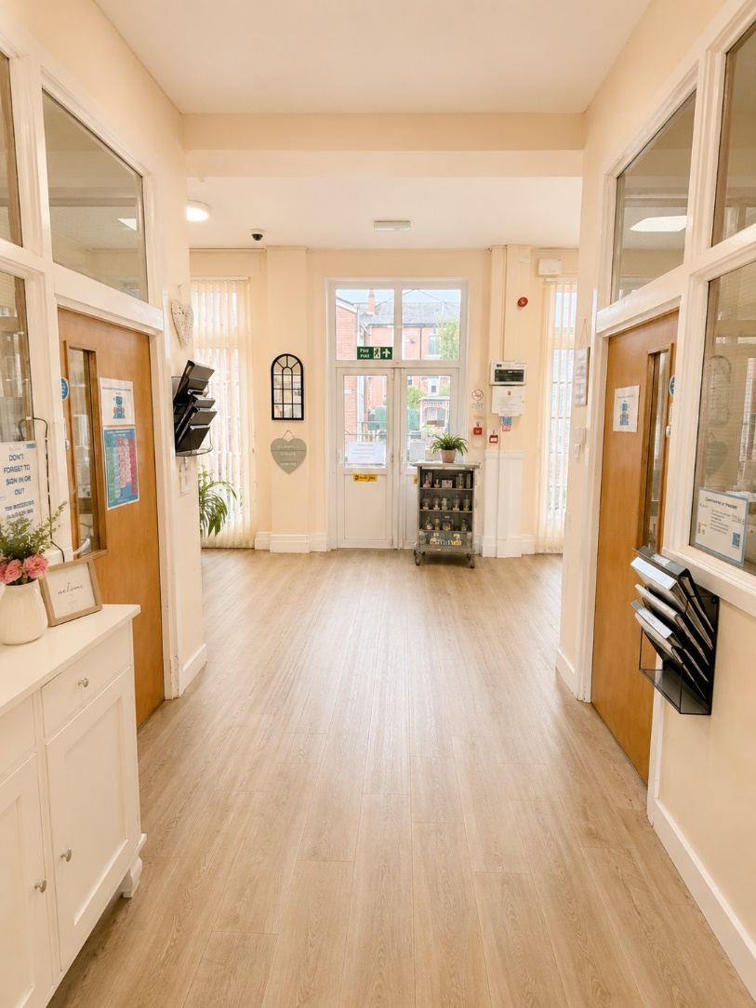
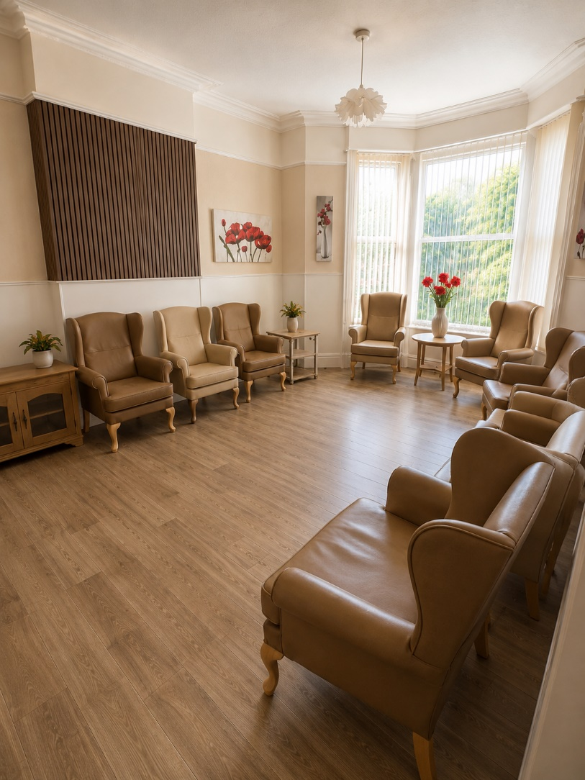
Our staff are always available to offer friendly guidance and support whenever needed, ensuring every resident feels secure, comfortable, and at ease within their home.

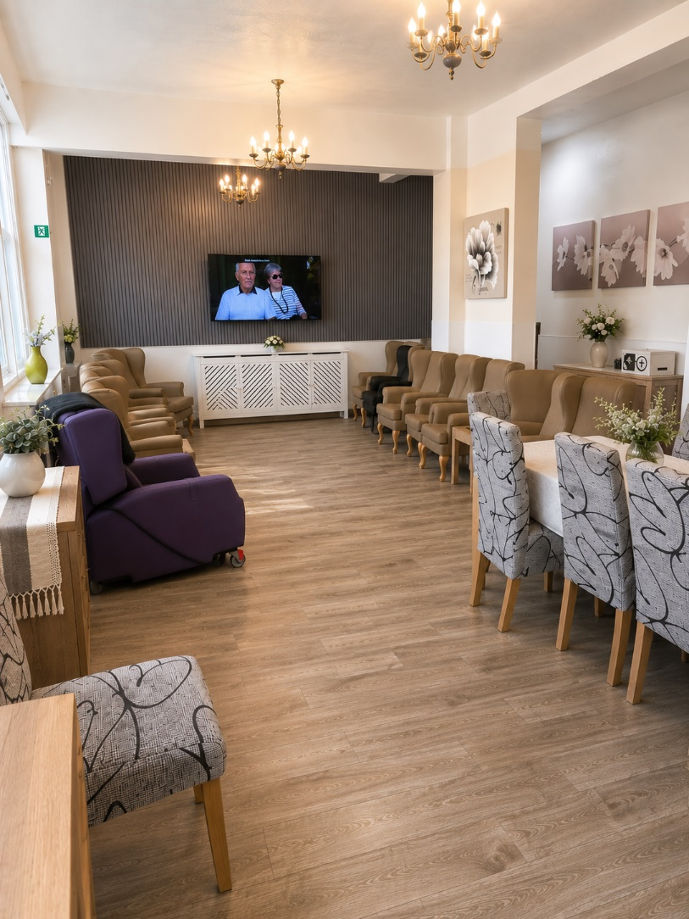
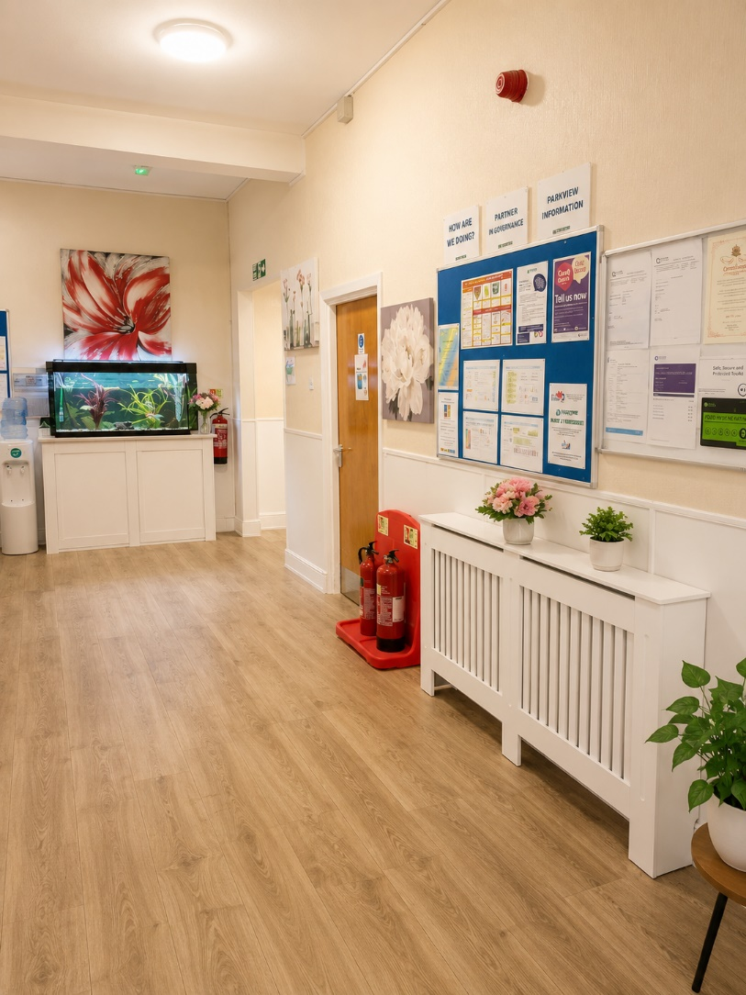

A HOME FOR EVERYONE
At Parkview Residential Home, our environment and lifestyle are designed to support and enrich the lives of all residents, not just those living with dementia. We provide a welcoming and inclusive home where everyone is encouraged to live well, stay active, and enjoy a wide range of meaningful experiences based on their own interests and abilities.
LIFESTYLE AND ACTIVITIES
We offer a varied programme of activities and experiences to promote enjoyment, choice, and social connection. This includes regular themed lunches that bring residents together to enjoy different foods and cultural experiences in a relaxed and social setting. We also arrange outings into the local community, giving residents the opportunity to enjoy fresh air, new surroundings, and time out with friends and staff.
PAMPER PARLOUR AND WELLBEING
Our pamper parlour provides a calm and relaxing space where residents can enjoy a little extra comfort and self-care. From hair and beauty treatments to simple moments of relaxation, we focus on wellbeing, dignity, and helping residents feel good about themselves.
SUPPORTING EVERY INDIVIDUAL
Everything we do is centred around individual choice and enjoyment. Whether residents prefer quiet time, group activities, or going out, we aim to provide opportunities that suit everyone and promote a fulfilling daily life within a supportive and inclusive home.
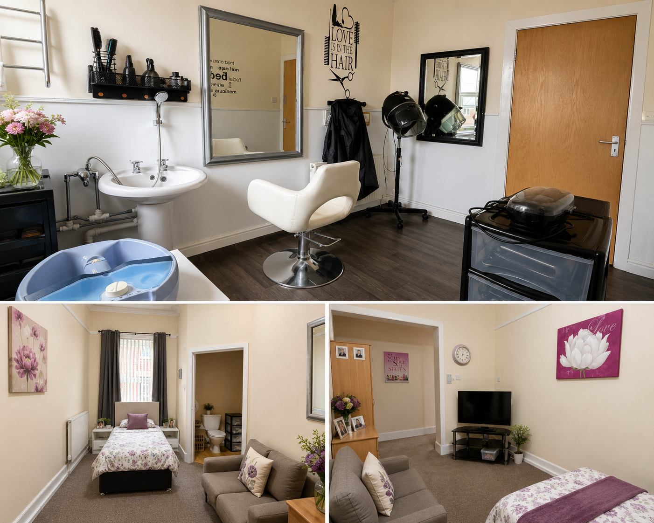
The first month at Parkview is a trial period to ensure residents are happy with their decision to stay. At the end of the month, residents and families can decide whether to remain at Parkview or move elsewhere. Support will be provided if alternative accommodation is needed.

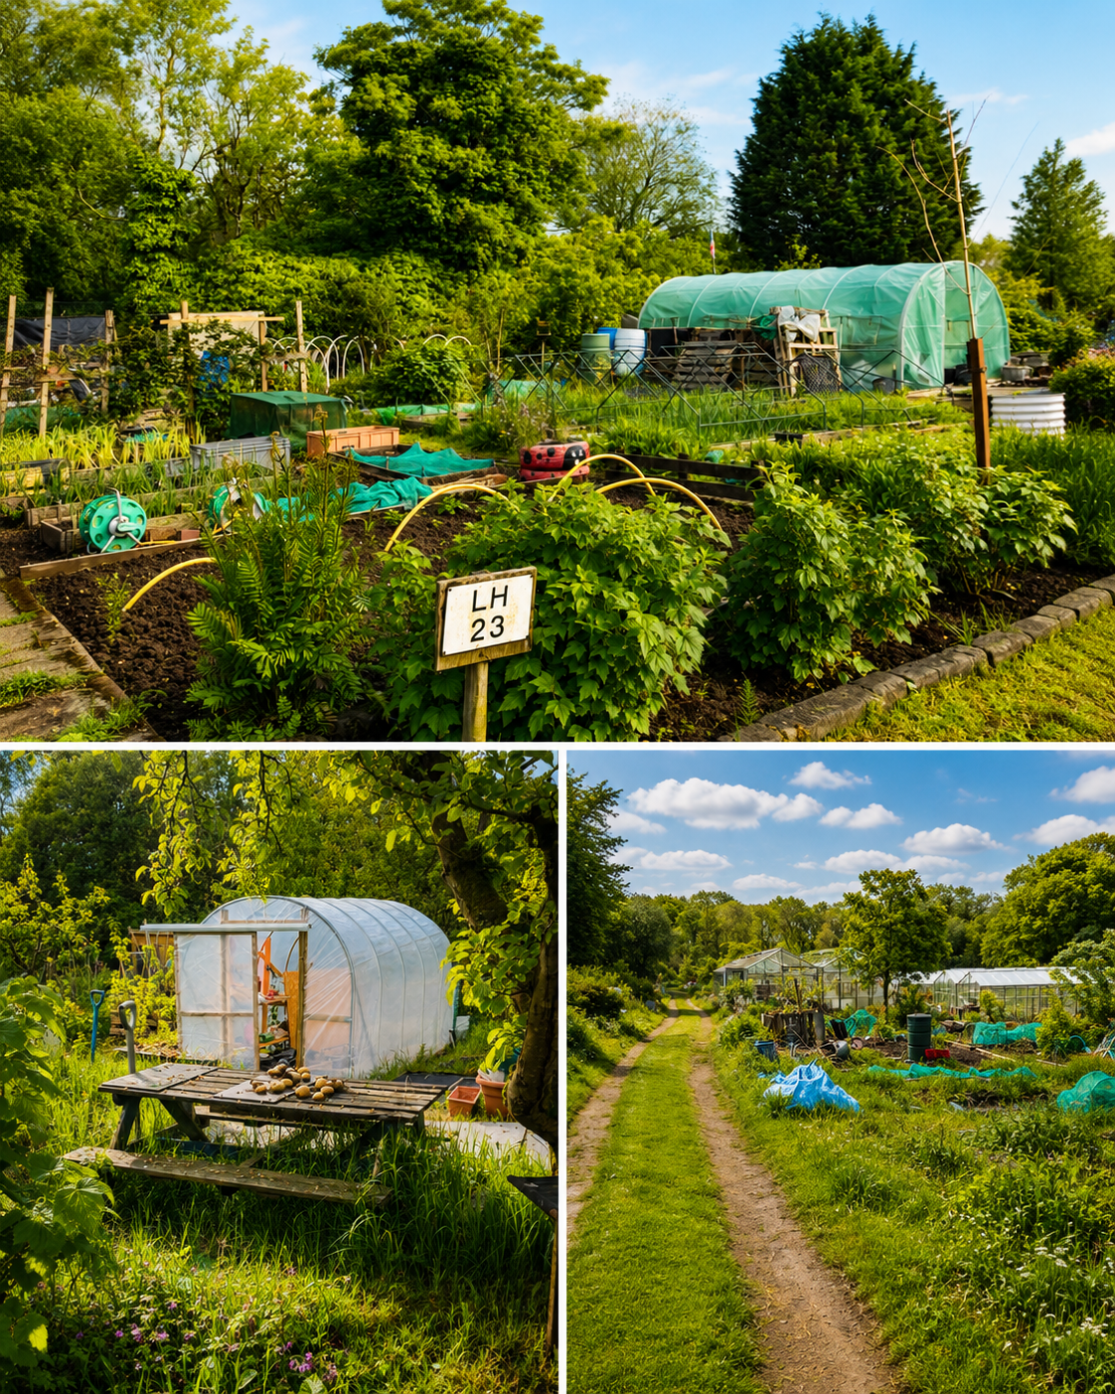
WELLNESS AND WELLBEING
At Parkview Residential Home, we place a strong focus on overall wellness, supporting the physical, emotional, and social wellbeing of every resident. We understand that wellbeing is about more than care needs; it is about feeling comfortable, supported, and able to enjoy daily life in a meaningful way.
We encourage healthy routines, regular movement, good nutrition, and access to activities that promote both body and mind. Equally important is emotional wellbeing, so we create opportunities for relaxation, social interaction, and enjoyable experiences that help residents feel connected and valued.
Our team works closely with residents to support individual preferences and choices, helping each person to maintain a sense of purpose, independence, and confidence. Through a caring and supportive environment, we aim to promote wellbeing in every aspect of life at Parkview.
ACTIVITIES AND COMMUNITY LIFE
- Weekly activity planners, newsletters and posters are available.
- Activities, events and outings are organised regularly.
- Residents are supported to maintain hobbies and social connections.
- Equipment is available to support residents with sensory impairments.
- Activity coordinators arrange events suited to residents’ interests and needs.

DINING EXPERIENCE
At Parkview Residential Home, mealtimes are an important part of daily life and are designed to be enjoyable, relaxed, and flexible for all residents. We offer a choice of well-balanced, freshly prepared meals each day, with different options available to suit individual tastes, dietary needs, and preferences.
We also have a quiet dining room available for residents who prefer a calmer, more peaceful environment during mealtimes, helping everyone to dine in a way that feels most comfortable for them.
We promote a strong sense of community within the home, and staff often sit and have their meals alongside residents, encouraging conversation, companionship, and a warm, homely atmosphere during mealtimes.
Residents are encouraged to help themselves to drinks throughout the day to support independence and choice. In addition, staff regularly circulate the home with a drinks trolley, ensuring everyone has easy access to refreshments.
Family and friends are always welcome to visit, and refreshments can be provided for them on request from staff, helping to make visits as comfortable and welcoming as possible for everyone.
Residents may keep personal food treats brought by visitors.
Food must be safely stored according to hygiene regulations.
Stored food will be labelled individually and made available on request.
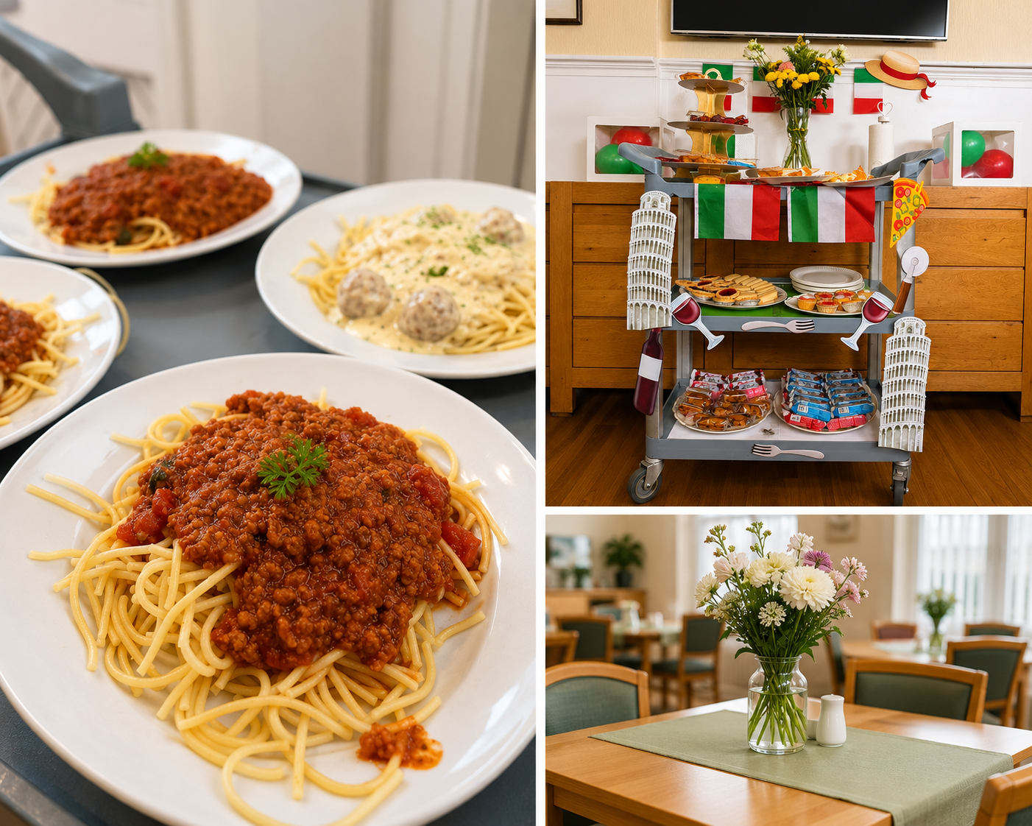

MEALS
Meals are prepared on-site using fresh produce where possible. Menu choices and themed meals are offered regularly.
MEALTIMES
- Early morning drinks – 7:00am
- Breakfast – 8:30am–10:30am
- Tea & coffee – 11:00am
Visitors may also be provided meals with reasonable notice.
- Lunch – 12:30pm–1:30pm
- Evening meal – 4:30pm–5:30pm
- Supper/tea & coffee – 6:00pm–9:00pm

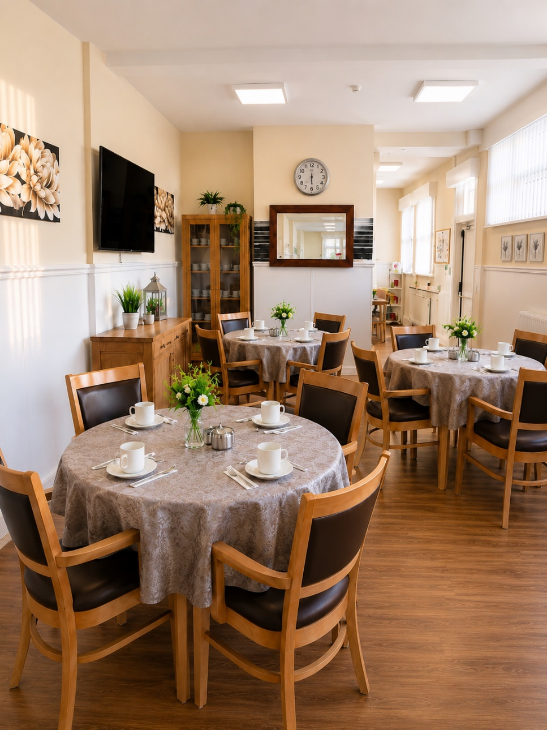
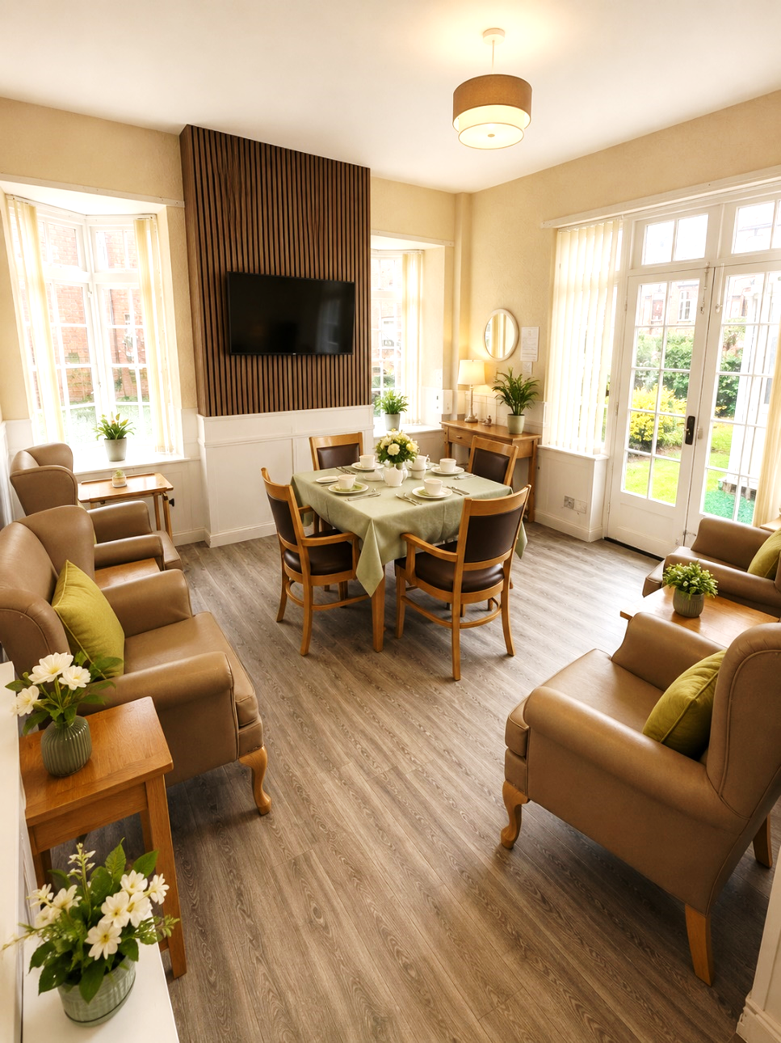

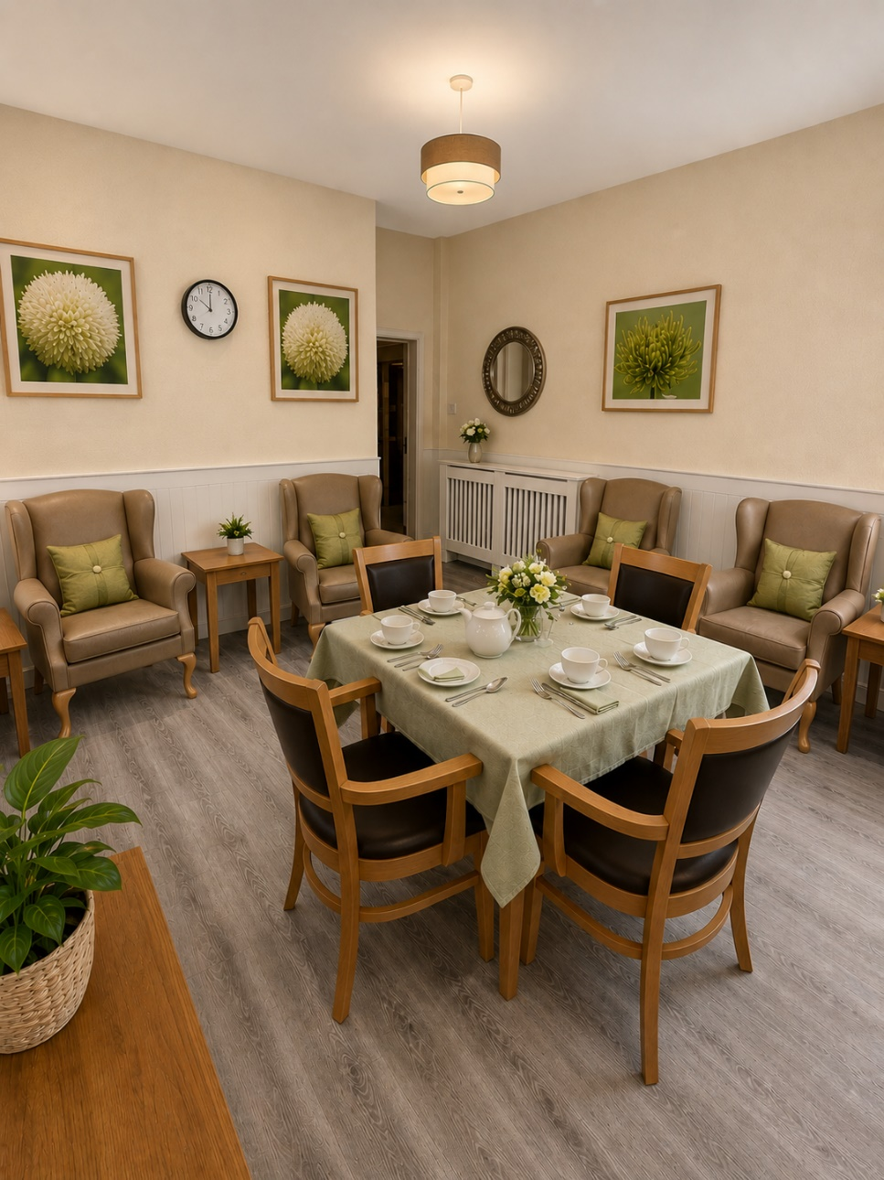
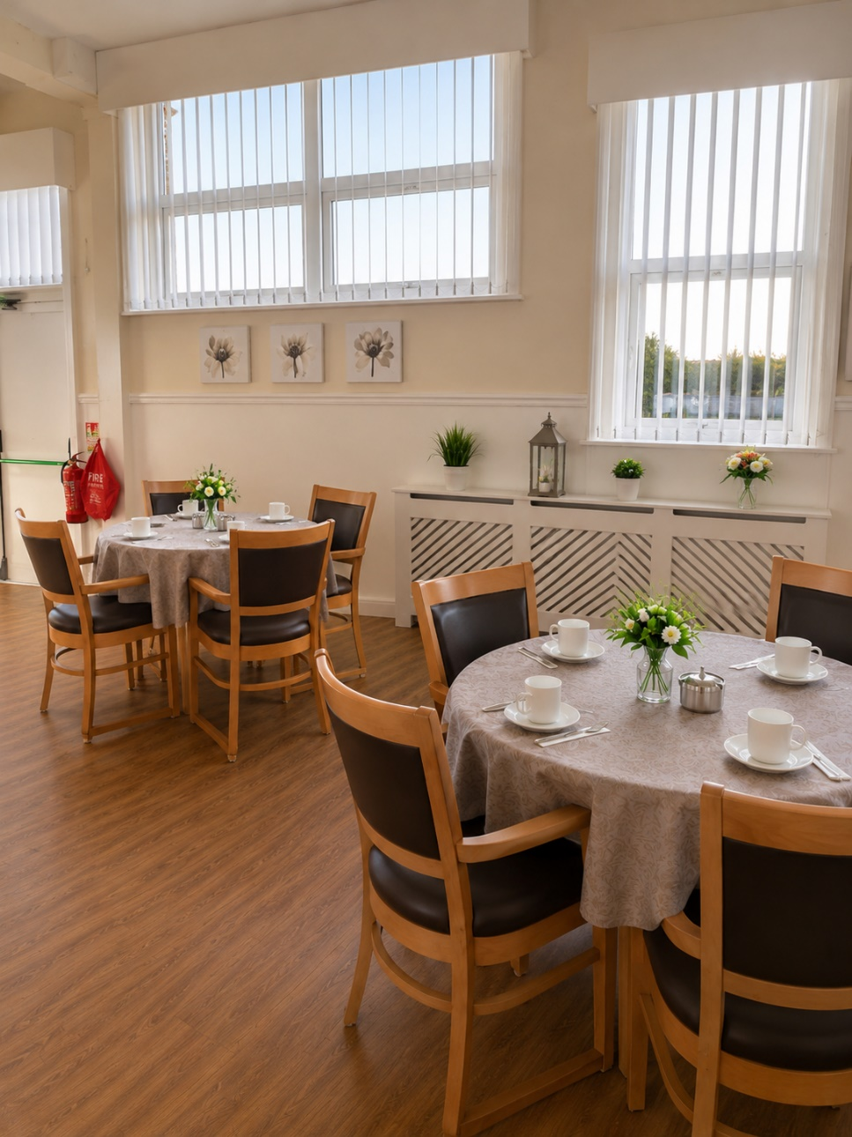

WHAT WE DO

- Learning culture - We have a proactive and positive culture of safety based on openness and honesty, in which concerns about safety are listened to, safety events are investigated and reported thoroughly, and lessons are learned to continually identify and embed good practices.
- Involving people to manage risks - We work with people to understand and manage risks by thinking holistically so that care meets their needs in a way that is safe and supportive and enables them to do the things that matter to them.
- Medicines optimisation - We make sure that medicines and treatments are safe and meet people’s needs, capacities and preferences by enabling them to be involved in planning, including when changes happen.
- Infection prevention and control - We assess and manage the risk of infection. We detect and control the risk of it spreading and share any concerns with appropriate agencies promptly.
- Safe and effective staffing - We make sure there are enough qualified, skilled and experienced people, who receive effective support, supervision and development. They work together effectively to provide safe care that meets people’s individual needs.
- Safeguarding - We work with people to understand what being safe means to them as well as with our partners on the best way to achieve this. We concentrate on improving people’s lives while protecting their right to live in safety, free from bullying, harassment, abuse, discrimination, avoidable harm and neglect. We make sure we share concerns quickly and appropriately.
- Safe systems, pathways and transitions - We work with people and our partners to establish and maintain safe systems of care, in which safety is managed, monitored and assured. We ensure continuity of care, including when people move between different services. Provide person-centred care tailored to each resident’s individual needs, preferences, and routines
- Continuity of care - We continuously improve our service to provide the best possible quality of life for residents.
- Responsive - Parkview aims to respond quickly to changing resident needs by: Keeping care plans updated, explaining care and medication clearly, supporting residents to express their views and taking complaints and concerns seriously
- Well Led - The home aims to provide strong leadership through: Visible and approachable management, Confidential handling of personal information, Compliance with legal data protection requirements and communicate honestly when issues arise.

WHAT WE DON’T DO
- We do not provide one-size-fits-all care
- We do not remove personal choice or independence from residents
- We do not create an institutional or hospital-like environment
- We do not ignore dignity, privacy, or respect in any aspect of care
- We do not treat residents as a group instead of individuals
- We do not discourage family involvement or open communication
- We do not provide care without listening to residents and their wishes

FAMILY REASSURANCE
Moving a loved one into a care home is never an easy decision, and we understand the emotions and concerns that families may feel. At Parkview Residential Home, we are here not only to care for our residents, but also to support and reassure their families every step of the way.
We provide a safe, warm, and supportive home where residents are cared for with dignity, compassion and respect always. Families can feel confident knowing their loved ones are in the hands of trained staff who are available 24 hours a day to provide consistent, person-centred care.
We believe families should always feel involved and informed. We encourage open communication and strong relationships, ensuring you are kept up to date and can remain closely connected to your loved one’s daily life.
You can expect:
- 24-hour care and support - ensuring help is always available when needed
- A safe and secure home - where wellbeing and comfort are our priority
- Kind, familiar staff who build trusting relationships with residents
- Regular communication and involvement - so families are never left wondering
- Support with daily needs - promoting comfort, dignity, and independence
- A welcoming environment for visits - where families are always encouraged to spend time together
- Peace of mind - knowing your loved one is cared for with compassion every day
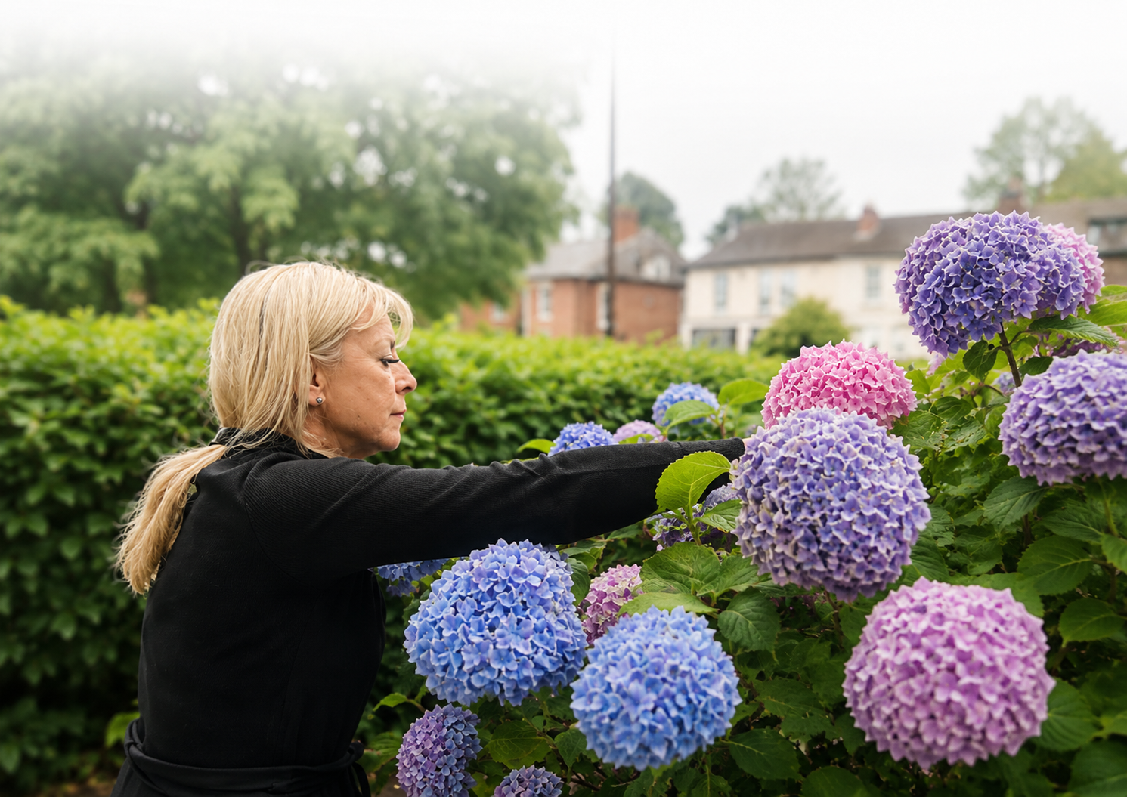
At Parkview Residential Home, we aim to ease the worry families may feel and replace it with reassurance, trust, and confidence that your loved one is truly at home.
We are committed to preventing abuse and inappropriate behaviour. Inappropriate behaviour includes physical, sexual, emotional or financial abuse. We encourage that concerns are reported immediately and we will investigate complaints and keep residents and relatives informed

IMPORTANT INFORMATION - MOVING IN TO PARKVIEW

Nurse Community Services
Community nurses may provide specialist support with:
- Wound care
- Blood tests
- Continence management
Staff can arrange access to specialist healthcare services where needed.

Key Workers
Each resident is allocated a Key Worker/Care Worker who:
- Helps identify care needs
- Supports care planning
- Monitors wellbeing and health goals
Residents can raise concerns about their Key Worker with the Registered Manager.

Service User’s Checklist
Residents are advised to bring:
- Day clothes and nightwear
- Underwear and slippers
- Toiletries
- Spectacles, hearing aids and mobility aids
- Medication and NHS medical card
- Personal items such as radios or TVs
Clothing should be labelled where possible. Laundry services are provided, though dry cleaning is at the resident’s expense.

Shopping
Residents may be accompanied shopping by staff or activity organisers.
Transport
Transport and escorts can be arranged for appointments.
Medical Services
Residents may keep their own GP or register with a local GP. Staff can assist with arrangements.
A Home visits from Physiotherapist & Chiropodist Can Be Arranged this may be arranged through NHS or private services.
Dentist or Optician
Residents can request dental or optical appointments either in the home or externally.
Medication
- Medication is managed safely by trained staff.
- Residents may manage their own medication where appropriate and agreed.
- Visitors should not bring additional medication supplies.
Personal Care
Care plans are developed with residents, staff and relatives where appropriate. Residents are encouraged to take part in all care planning and reviews.

OUR FAMILY
At Parkview Residential Home, we believe care is about more than support with daily needs — it is about belonging, connection, and feeling truly at home. Together, residents, families, and staff form one community where everyone is valued, listened to, and respected.
We support each person to live well, maintain independence, and enjoy meaningful days in a safe and welcoming environment.
Our commitment is to provide not just care, but a true home where relationships matter, kindness is at the heart of everything we do, and every individual is treated as part of our extended family.
Team Parkview — Where Care Feels Like Home
OUR TEAM
Dedicated professionals providing compassionate care in the place our residents call home - because we do not believe our residents live in our workplace, we believe we work in their home.


Wendy is the Manager and Director of Services, bringing over 8 years of dedicated leadership to the home. With a strong nursing background, Wendy is passionate about delivering high-quality, person-centred care and ensuring residents feel safe, valued, and supported every day. Her experience and compassionate approach help create a warm and professional environment for both residents and staff.

Mahendra is the Owner of the home and is dedicated to providing a welcoming,
comfortable, and high-quality care environment for all residents. With a strong
commitment to excellence and resident wellbeing, Mahendra supports the team in
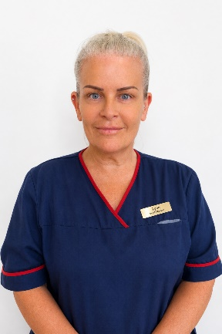
creating a home where people feel respected, cared for, and part of a community.

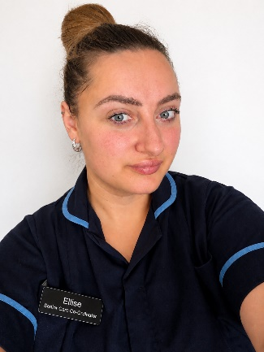
Lynn is the Deputy Manager and is committed to maintaining a positive and supportive atmosphere within the home. She works closely alongside the management team and care staff to ensure residents receive compassionate, respectful, and consistent care at all times.

Ellise is the Senior Care Coordinator and works closely alongside the Manager in
overseeing the daily running of the home and supporting residents’ wellbeing.
With excellent organisational skills and a caring nature, Ellise works closely with
residents, families, and staff to ensure care is tailored to individual needs and
delivered to the highest standard.

CONTACT US
We’re here to answer your questions, schedule a visit, or help you learn more about the care we provide at Parkview Residential Home.




Parkview Residential Home
54 Chorley New Road, Bolton, Lancashire, BL1 4AP
(01204) 363105
manager@parkviewbolton.co.uk

RAISING CONCERNS, COMPLAINTS AND COMPLIMENTS
At Parkview Residential Home, we are committed to providing high-quality care and support. We value all feedback from residents, relatives, representatives and visitors, as it helps us improve our services and ensure residents feel safe, respected and listened to. You have the right to raise a concern, make a complaint or give a compliment without fear of discrimination, unfair treatment or any impact on the care you receive.

IF YOU HAVE A CONCERN
Many concerns can often be resolved quickly and informally by speaking to: A member of staff, Your Key Worker, The Senior Staff in Charge or The Registered Manager. We encourage residents and families to raise concerns as soon as possible so that we can work together to resolve them promptly.

COMPLIMENTS AND POSITIVE FEEDBACK
We also welcome compliments and positive feedback about our staff and services. Compliments help us recognise good practice and celebrate excellent care.
Compliments can be shared:
- In person
- By telephone
- In writing
- Through surveys or feedback forms
OUR COMMITMENT TO YOU
Parkview Residential Home is committed to:
- Listening to residents and families
- Treating all complaints fairly and respectfully
- Learning from feedback
- Improving the quality of our care and support
- Ensuring residents feel safe, valued and heard at all times
EXTERNAL ORGANISATIONS
If you are unhappy with the outcome of your complaint, or wish to speak to an independent organisation, you may contact:

Bolton Council Adult Services
Le Mans Crescent, Bolton, BL1 1SA
Telephone: 01204 337288

Local Government and Social Care Ombudsman
PO Box 4771, Coventry, CV4 0EH
Telephone: 0300 061 0614
Email: advice@lgo.org.uk
Website: https://www.lgo.org.uk/

Integrated Care Board (Bolton PCT)
St Peter’s House, Silverwell Street, Bolton
Telephone: 01204 462000

Care Quality Commission (CQC)
Citygate, Gallowgate, Newcastle upon Tyne, NE1 4PA
Telephone: 03000 616161
Fax: 03000 616171

